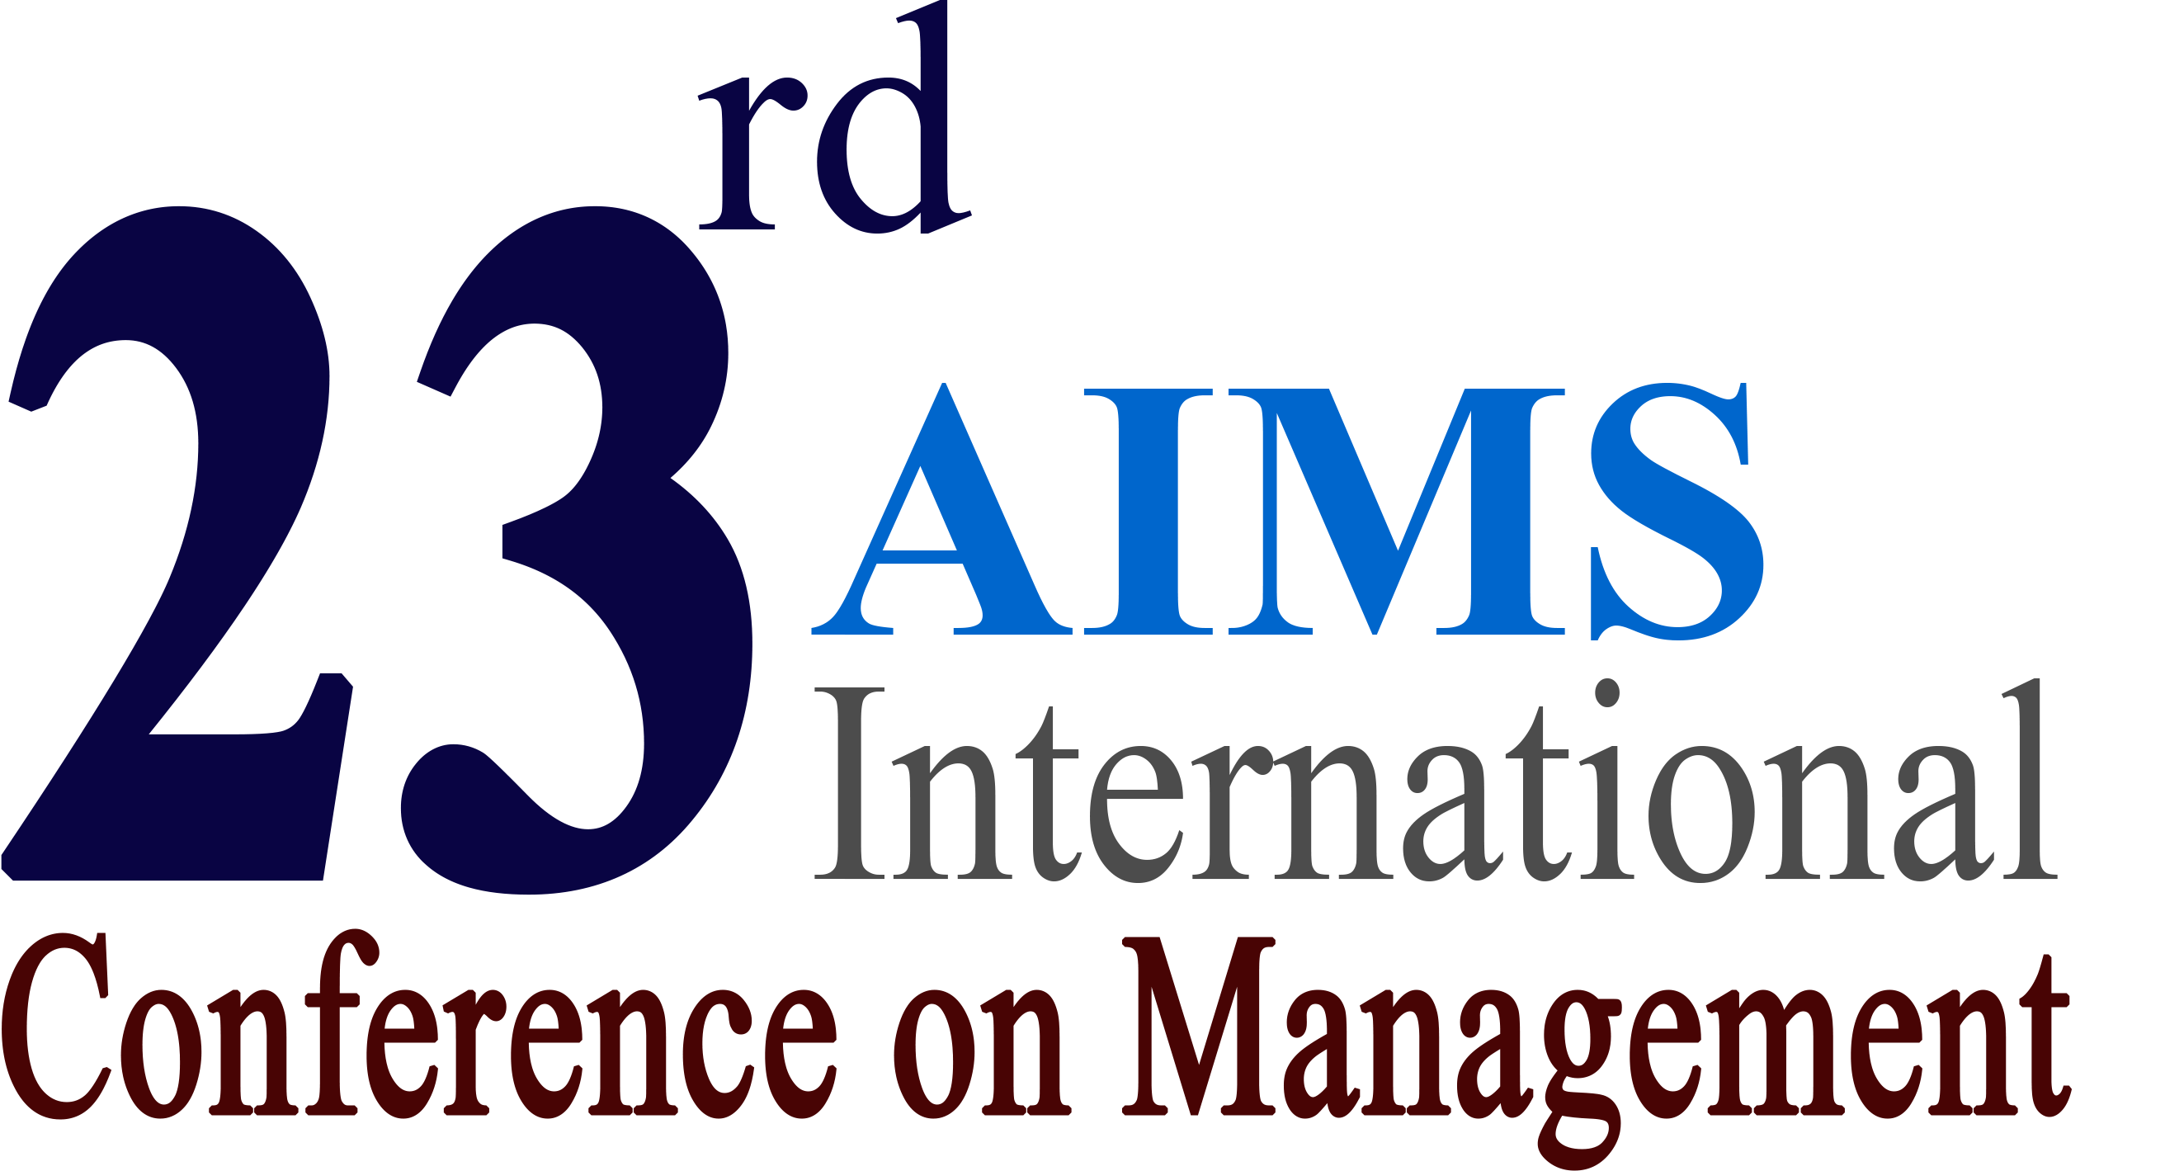
Indian Institute of Management, Shillong

December 3-5, 2025

GUIDELINES FOR CONFERENCE PROCEEDINGS

Authors interested in getting their papers published in the conference proceedings are requested to follow the guidelines given below:

- The conference proceedings will be published in a CD-ROM format and will be available to each conference participant. The proceedings will have an ISBN. Additional CR-ROMs, if available, can be bought at the conference site at a nominal price.
- The text should be single-spaced with 10 point New Times Roman Font in MS WORD. Please ensure that all variables (in mathematical expressions) are in italics and NOT bolded. An electronic version in MS WORD should be uploaded through Google Form. No hard copy is required. No article can be accepted for the proceedings without an electronic copy in WORD.
- If your paper has been a given a number B0123, name your files as B0123.doc.
- A Sample Paper is posted on the conference web site to help you format your paper.
- Please write the paper reference number, title, authors’ names, addresses, e-mails etc. on the cover page. The manuscript should be prepared on standard A4 size with a margin of one inch margin on all four sides. Use of footnotes is strongly discouraged.
- Manuscripts in poor form will automatically be rejected. Some examples of poor form are: too small or large margins, too small or large font size, different font type, etc.
- There is a limit of maximum fifteen pages per manuscript. For longer manuscripts, please enclose a payment for excessive pages at the rate of US $10 per page. Manuscripts exceeding fifteen pages and without a payment for excessive pages will not be included in the proceedings. The payment should be made payable to “AIMS International.”
- Since there will be no further opportunity of editing, it is strongly suggested that you have your paper checked with a competent colleague or professional for English syntax, grammar, etc. Papers with writing problems will not be included in the proceedings.
- At least of one of the authors must pre-register for the conference for paper to be included in the proceedings. Articles without the pre-registration fee cannot be included in the Proceedings.
- It is not mandatory for participants to submit full papers. In fact, you should submit full paper as per these guidelines only if you wish the same included in the Proceedings.
- It is assumed that the papers submitted are the original works of the authors and no copyrights have been violated. AIMS International will not be responsible for any such violations.
- Manuscripts should be uploaded through Google Form

(We are not responsible for manuscripts sent through email)

All materials must be received by October 31, 2025. It may be possible to accept late submission by November 15, 2025 if accompanied with a late fee of Rs. 1,000.

Materials received after the deadline shall not be included in the proceedings. Manuscripts in violation of any of the above conditions will not be included in the proceedings. Due to tight schedule no such communication will be given to the submitting authors. Inconvenience, if any, is deeply regretted.

