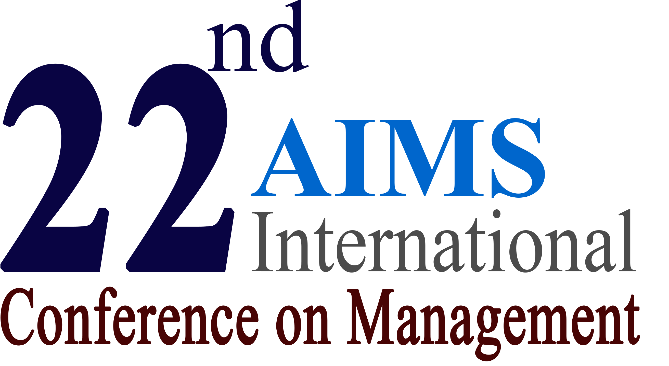
Indian Institute of Management, Kozhikode

January 2-4, 2025

Registration Form for Video/ In-Absentia Papers
(This form is valid only for the participants working in India)

NAME: Prof./Dr./Mr./Mrs./Ms. (Last Name) (First Name)
Abstract Reference Number of the Paper: _________
Organization/ University: _________________________________________________
Postal Address:________________________________________________________________
_____________________________________________________________________________
City: _________________ State: ___________________ ZIP: ______________ Country: _______________
Phone::______________________________ Mobile: ___________________________________
E-mail: __________________________________ Alternate E-mail: ____________________________
- Registration Fee (Please tick only one):
Early Bird Registration (received by October 31, 2024) … Rs. 3600
Regular Registration (received by November 30, 2024) … Rs. 4600
Late-Registration (received after November 30, 2024) … Rs. 5800

- Additional paper/s submitted (Rs. 2400 each) Rs. ______ ⁽²⁾

- Certificate required for co-authors (Rs. 1000 each) Rs. ______ ⁽³⁾

- Late Fee (for full paper submission after November 15, 2024) Rs. 1000

- DOI by CrossRef (Optional) (Rs. 590 each paper) Rs. ______

SUBTOTAL Rs. ______

- Membership (AIMS International/ INFOMS) Discount (10% of Subtotal) .. Rs. ______ ⁽⁵⁾

NET PAYABLE AMOUNT Rs. ______

Mode of Payment: NEFT, Draft/ Cheque, UPI
Confirmation Number: _________________________________ Date: ____________________

- Registration link of conference website includes details of everything included in the registration fee and refund policy.
- Payment using Net Banking: Account Name: AIMS International, Bank: ICICI Bank, Account Type: Current, Branch: Kareli Baug, Vadodara (or Baroda), Gujarat, Account Number: 0248-0500-2504, IFSC Code: ICIC0000248 (Not Valid for any UPI payment)
- Payment using DD/ Cheque: Send Cheque/ DD in favor of AIMS International to: AIMS International, 1-B Vrundavan Park, Sama Road, Vadodara 390008
- Payment using UPI: Please use following QR Code for the payment


- Please email this form to aims22@aims-international.org

⁽²⁾ Please include abstract numbers separately, ⁽³⁾ Please include name/s of author/s, ⁽⁵⁾ Please include your membership details

