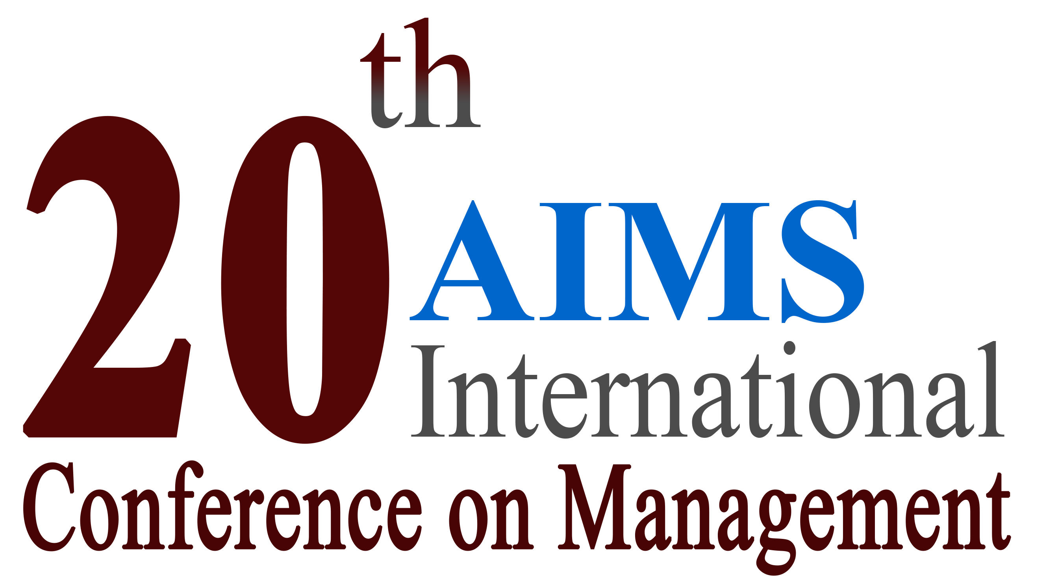
Indian Institute of Management, Kozhikode

December 28-31, 2022

Registration Form for Participation

NAME: Prof./Dr./Mr./Mrs./Ms. ___________________________________________________________ (Last Name) (First Name)
Organization/ University: _________________________________________________
Postal Address:____________________________________________________________________
______________________________________________________________________________
City: _____________________ State: ___________________ ZIP: ______________ Country: _______________
Phone::______________________________ Mobile: ___________________________________
E-mail: __________________________________ Alternate E-mail: ____________________________
- Registration Fee (Please tick only one):
Early Bird Registration (received by October 31, 2022) … $295
Regular Registration (received by November 30, 2022) … $345
Late-Registration (received after November 30, 2022) … $415

- Guest Registration Fee ($50 each): $ ______

SUBTOTAL $ ______

- Membership (AIMS International/ INFOMS) Discount (10% of Subtotal) .. $ ______ ⁽⁵⁾

NET PAYABLE AMOUNT $ ______

Mode of Payment (Tick only one): Credit Card (Visa/ Master Card), Wire Transfer, Draft/ Cheque, Online Transfer

Signature: ________________________________ Date: _______________________

- Registration link of conference website includes details of everything included in registration fee and refund policy.
- Please email us for the process and details required as per payment mode selected
- In order to maintain payment security, please do not send any bank/ credit card detail on this form

⁽⁵⁾ Please include your membership details

