Managing Reliability in Printing Industries in India: Role of Information System
  ISBN: 978-81-924713-7-2 | Poulomi Mukherjee Mondal  Bengal Engineering and Science University  (poulomi.mukherjeemondal@gmail.com)  Shankar Chakraborty  Jadavpur University  (s_chakraborty00@yahoo.co.in)

To cope up with the burgeoning costs of input materials like printing ink and paper, as well as cost of retaining skilled employees, the SMEs need to reorganize business in printing. This could be achieved by updating the way printing organisations use the information available to them in the form of customer order as well as inputs from the shop-floor. This paper presents the case of a model information system adopted around appropriate business processes which ensures reliability and customer satisfaction.

- Introduction
  - Genesis Of Management Information System
The term ‘Management Information System’ (MIS) was first used in U.S. navy report on the application of computers to build a single integrated system to manage all the navy related actions and resources. The MIS idea caught on quickly throughout the organizational systems society, encouraged by a large number of subsequent reports and conferences sponsored by the American Management Association. MIS was an ‘information’ system because it gave information to the managers, not because it was full of technical information, though the distinction soon blurred as the idea of MIS spread.
The term ‘Management Information System’ (MIS) is synonymous with computer-based systems. Every person in the organization is a user of MIS. Organizations have people working at different levels of responsibility who have varying needs of information. The MIS offers to integrate the data from different functions and cuts across functions
Researchers see it as a system of collecting and analyzing data and generating reports. The main objective being solving of structured problems faced by managers of business organization. But it should also fulfill a number of other purposes as listed below:
- To provide a starting point to examine the forewarning that can originate both from within the organization or outside the organization.
- To computerize everyday operations, thus avoiding repetitive processes requiring human intervention in the dealing of standard tasks.
- To assist management in making routine decisions.
- To make available the information as required for non-routine decisions.
- To serve as a tactical weapon to add the competitive advantages.
- To increases competitiveness of the organization through cost reduction and increasing the processing speed of data which is essential for data available across organizational function, Management Information System is viewed as a transformational tool.
Planning, Coordinating, Organizing and Controlling can be appropriately done by intervention of MIS. It makes available information needed for strategy design as well as for routine activities of operations. Usage of information is different for different levels of management which also need to be formulated keeping in mind the goals and objectives of the organization. These different levels of management decision-making can be described as operational, tactical and strategic. So the information can be broadly classified as follows:
- Operational information: mainly generated from within the company, historical, comprehensive information on a daily or weekly basis, often quantitative, highly accurate, and narrow in scope.
- Tactical information: generated from within and outside the organisation, which includes data concerning current and projection about future performance, summarized information on sales by products, financial information and operations etc.
- Strategic information: generated and collected mainly from external or publicly available sources including information on economic indicators, technology forecasts, information regarding competitors, futuristic, qualitative, wide ranging, incomplete. Here, information is important; precision is not crucial.
Without information, the decision-making process remains incomplete and erroneous and managers are on the constant look out for superior quality information to improve their quality of decisions, which justifies the growth of information system. The design of MIS must take into account the information needs of various managerial levels, as well as the routine transaction processing needs of the total organization. Often survival strategies formulated in organizations ensure that the organization collects information and makes it available internally and process it so that the managers may use such insights for decisions quickly and effectively in pursuit of organizational objectives in a changing competitive environment. The information system acts like the Central nervous system which alerts the organization to respond to the opportunities and avoid threats. It is widely observed and acknowledged that the organizations with the best and most effective information systems (IS) are those that have clear and well-thought IS strategy.
The speed at which the organizations must gear up to the new market conditions and maintains a responsible MIS will play a major role in determining their success or failure in the changing and dynamic environment. It can give an organization sustainable competitive advantage by improving production, sales and administrative performance. Almost all the business organizations normally have some kind of information system for their routine managerial activities. Accounting rules, inventory control and market monitoring systems are the most traditional and common examples.
Organizations have always had some form of information systems, even if it was not recognized as such. Developments in the use of the new IS-based technology have gone through the following stages:
Stage Initial- EDP: At the initial stage of introduction of computers in business, they were mainly used to process data for particular business functions, such as accounting and billing. Electronic Data Processing departments had the ownership of the computer hardware, software programmes as well as the primitive processes because of the specialized skills needed to operate those complicated proprietory systems.
Stage 2 - Growth: The growth of Electronic Data Processing departments encouraged and helped managers to focus more on planning their organizations’ information systems. As the EDP activities crossed the borders of the routine processing of masses of standardized data, they began to be called Management Information System (MIS) departments. Figure 1.3 depicts the functional representation of MIS. MIS uses data captured in the different organizational processes such as from Customer Databases, Customer Satisfaction Surveys, Production Shopfloor Statistics, Financial Indicators from Stock Market or other sources It does not make any changes in those data. MIS can obtain information from internal and external sources.
Stage 3 Expansion – Decision Support System: Later on, when remote terminals were introduced, more than one department began to use the same system. Here Management information system went beyond data processing role and included the provision of a number of decision support systems (DSS). While MIS is aggregation of data that is internally generated for medium term usage in an organization, DSS is seen as improving quality of the decisions on ‘less everyday issues’ and solving ‘semi-structured’ problems.

Figure 1.1 Need of Information in an Organization

Stage 4 - Artificial Intelligence and Expert Systems: One of the fastest growing areas of information technology, artificial intelligence (AI) uses the computer to simulate some of the ways in which human beings think. The term artificial intelligence means the mock-up of human thought process in order to select the best mode of behavior, e.g. taking a decision or responding to a situation. Expert systems (ES) are a major application of AI. They act like a human ‘expert’ in analyzing unstructured situations. Expert systems are also called ‘knowledge-based’ systems since they are built on a framework of known facts and responses to situations.
It is believed that we are moving rapidly from industrial-based society to an information-based one. The application of computer technology to management information and decision support systems has certainly had an effect on how the managers perform their tasks and on how the organizations behave.

Scenario of Printing Industry in India: The Indian Printing Industry has been growing at a generally moderate but sustainable rate of 12% per annum. It includes more than 250,000 big, small and medium printers. The current annual turnover of the industry is more than INR 50,000 crores (USD 11 Billion).
The industry has experienced extensive changes in the last couple of decades. In 1990, India initiated a process of reforms aimed at coming off protectionism and implementation of liberalization of the economy. Privatization was initiated with the aim of integrating the Indian economy with the rest of the world economy. These changes forced the Indian Print Industry to modernize, by investing in the latest of technology and machinery. In recent years, the printing industry in India has seen reasonable levels of growth, owing to liberalized government, globalization and progress in mechanization and automation. Growth of the industry has grown fast due to the introduction of new technologies and machinery, improvement in quality standards and production capacities.
The printing industry in India is slowly progressing from the heavy machinery using industry to an industry which is more environment friendly and a more software-centric business. The Industry in India are today equipped with the latest computer controlled printing machines and flow lines for binding also, state-of-the-art digital technologies are used in pre-press. UV digital printing and inkjet technology are also on the rise in India. Introduction of global brands, rising advertisements and packaged items, and growth of the pharmaceutical industry have given a boost to packaging printing. According to sources from Print-packaging industry, as per an optimistic outlook of the industry, the package printing sector is growing at the annual rate of 17 percent, commercial printing at a rate of 10-12 percent and digital printing at robust 30 percent.
The digital printing industry is drastically transforming as new technologies & applications providing cost-effective and customized solutions percolate. Experts often forecasted cannibalization of offset by digital printing but it seems in the foreseeable future, offset and digital will not remain in the position of co-opetition that is it will not only co-exist, but will also complement each other- with offset taking the medium-to-longer jobs and digital performing on short-to-medium run lengths.
The booming Indian economy, increasing consumerism, entry of global brands in the country and opening of the sector to foreign investors are bound to offer growth opportunities to the industry.

Figure 1.2 Flowchart of a Typical Printing Process

Majority of printed works begins with the design phase, following the identification of the customer requirements and a production enquiry. Design work may begin on the customer’s premises, or perhaps at a design organization or publisher. It is here that a difficulty may arise, i.e. orders are usually carried out in response to customer demand and they usually have an individual customer specification. This results in production being job-controlled, as the combination of several printing jobs is rarely possible.
Drawing up the specification is a key task while producing a printed job. Majority of the problems arise from poor specifications than from any other single source. The role of the specification is to define the requirements: what will be supplied to the printer, what processes are to be used and what the finished products will be like. It will also define the types of proofs that will be required as a means of monitoring the process.
The process of commercial printing starts with the process of typesetting and copy fitting. Desktop publication provides the platform for typesetting and page-makeup which also includes addition of black and white or color photographic artwork in the matter. The photographic materials may be generated from black and white line or tone reflection originals or color line or tone reflection or transmission originals. Line works or artworks are reproduced by the process of image scanning where color separations are produced by the process of scanning using digital scanners. Image scanners which breakup the images into printing primary colors (cyan, magenta, yellow and black) play a major role in reproduction of images.
Where the graphic elements and text elements of the work are produced separately, it is necessary to assemble these together prior to making the printing plates which is the image carrier.
For color work, it is common to use film origination and plan on to a transparent film base. There are the following two basic steps in this operation:
- Planning: To determine in advance where each element of the text and graphics is to be placed.
- Assembly: Various elements are physically located in position according to the plan.
Before any other operation starts, a plan or layout is prepared. This is a technical drawing showing the location of all image elements as they will finally appear on the printing plates. The layout is accompanied with a form of dummy or ‘mock-up’ of the final job. This ‘mock-up’ or dummy gives the planner the following information:
- Number of pages,
- Final trimmed print size, and
- Location of text or graphics in the printed material.
The printing department also provides the following information to the process of print planning:
- Sheet size on which the work is to be produced, and
- Technical specifications of the printing machine which will print the work.
Once the printing press or machine is known, it gives information about the following parameters:
- Plate size,
- Allowance for grip,
- Whether the job is to be printed one color at a time or at a single shot, and
- Will the sheets be turned over and backed up (perfected) on a second run through the press or will they be perfected in one pass on a perfector press.
The print finishing department provides the information such as the best method for folding sheets into individual sections or signatures, where and how the sheets and folded sections should be trimmed and the allowance that needs to be provided, coding system for indicating the individual sections for gathering, collating and making up into the final publication.
With all these information about the final job, the imposition scheme for the layout is created. The imposition shows the location of each page or the location of images with relation to the paper, so that the paper may be converted to the finished output through least intervention or wastage. The imposed layout for the sheets is assembled on transparent plastic bases or acetate films. The imposed layouts are either photographically transferred to the printing plates or image carriers. The image carriers are preferred for cheapness, stability and surface properties. The plates need to be grained, anodized and coated before the transfer of image. An intermediate document termed as a proof is produced before the actual printing operation starts. There are various types and qualities of proof depending upon the purpose for which they are intended. They may be used externally for the information to the customer who may wish to have the preview of the finished work. The printing process involves passing the chosen substrate through the printing cylinder and then transferring the image from the plate mounted on the plate cylinder and duly inked to the substrate on the image cylinder. Having printed the job, the sheets pass to the print finishing department for treatment and making into final form. The major operation in this area includes cutting, folding, assembling and make-up into books and magazines. In addition to these, there is a multiplicity of operations including foil stamping, thermo-graphing, embossing, varnishing, laminating, punching, drilling, perforating, numbering, gumming etc. Final quality checks for the finished goods for perfect and imperfect pieces are done at this point.
The printing process as a whole has a number of sub-systems or processes (e.g. typesetting, scanning, plate-making, printing and so on) and each of these uses the output from the previous process as its input. The output from each process can be used to control and monitor the quality before proceeding to the next stage.

Quality Function Deployment: It is necessary to convert the user based definitions of quality into product based definitions. In the process of such transformation the voice of customer is converted into design specification through quality function deployment (QFD). This QFD tool is used for translating customers’ needs into technical requirements of the product. It is a process analysis approach to quality planning that begins with the identification of customers’ expectations and ends with the transfer to operations. Now a days this approach has been accepted world wide and the technique is used effectively in determining engineering characteristics, parts characteristics, key process characteristics and production requirements (Jitendra Sharma; 2009).
In the case of printing decision, customer attributes i.e. the voice of customer can be tabulated in the form of quality requirements and corresponding voice of technologist can also be identified.

Sl. No. | Voice of Customer | Voice of Technologist
1
2 | Internal quality | Colour Correction Ink Drying
3 | External quality | Finished copy dimensions Colour Accuracy Delivery Schedule
4 | Size accuracy | Cutter dimensions Feeder Unit alignment

- Road To Reliability: Vendor Appraisal and Vendor Development
One major task of the manufacturing function in printing organizations is vendor selection, vendor development, and acquisition of required materials, services and equipment for all types of business organizations. By its very nature, the purchasing function is an integral part of business management. In today’s competitive operating environment, it is impossible to successfully produce low cost, high quality products without satisfactory and reliable vendors. Thus one of the most important purchasing decisions is the selection and maintenance of a competent group of suppliers/vendors. The selection of competent suppliers has long been regarded as one of the most important functions to be performed by a purchasing department. For many printing organizations, purchase of materials from vendors account for a large percentage of their total operating costs.
Suppliers are those organizations that furnish materials and services to the buyer operations. Good management and control over the suppliers is necessary to keep production costs at the minimum level. Printing organizations often use checklists, with varying weighting criteria, in order to evaluate the performance of the suppliers. Criteria for the selection of an appropriate supplier include those, as listed in Table 3.1. For some organizations, it is not sufficient to negotiate strictly on price, but also to understand how a particular product will perform in a manufacturing operation. For example, paper for a printing operation may be purchased at a low price. However, if it continually tears during the printing operation, causing several shutdowns, what is gained in the price of the raw material is lost during the processing operation.
Thus, each criterion is graded (very good to very poor) and the criteria themselves are weighted according to their importance to the buying printing organization. A sample evaluation checklist is exhibited in Table 3.2. The rating sheet evaluates both the product and the supplier organization. The evaluation criteria for the product cover quality through warranty conditions and the evaluation criteria for the supplier encompass technical capability through environmental awareness. Vendor selection decisions are complicated by the fact that various criteria must be considered in this decision-making process. The detailed analysis of the criteria for selection and measuring the performance of vendors has been the focus of many academicians and purchasing practitioners from long back. There are various quantitative approaches to vendor appraisal and these can be grouped into the following three broad categories:
- Linear weighting models,
- Mathematical programming models, and
- Statistical /probabilistic approaches.
By far, the most utilized approach has been the linear weighting models. Linear weighting models place a weight on each criterion (typically subjectively determined) and provide a total score for each vendor by summing up the vendor’s performance on the criteria multiplied by these weights. In mathematical programming models for vendor selection, linear programming, mixed integer programming and goal programming techniques are most widely used. Cluster analysis, stochastic models and linear weighting method by incorporating probabilities for the criteria weights are dealt under the domain of probabilistic approaches for vendor selection.
In linear weighting models, the printing organization assigns an importance factor from 1 to 5 to various criteria, arranged in descending order of importance. The criteria themselves have a quantitative rating of 5 (excellent) to 1 (terrible). The last column of Table 3.2 is the product of weighting and importance factor. For example, if a supplier has a product whose quality (importance factor = 5) is judged fair (weighting = 3), then the score will be 15 (5 x 3). If a supplier whose management competence is being evaluated (importance factor = 3) is given a rating good (weighting = 4), then the score will be 12 (3 x 4).
Over the years, well established printing organizations build up large databases of suppliers that they either use frequently or hardly at all. In order to reduce cost, the printing organizations have or are in the processing of reducing the number of suppliers that are used by the organization. The reasons for this are enlisted as below:
- Administrative costs become lower.
- When a supplier knows that it is one of a few suppliers, and furnishes a large proportion of products to a printing organization, then the purchaser can exercise more power over the supplier regarding the contract terms. It facilitates management of the purchasing function.
- A buyer organization can be able to reduce its number of purchasing staff.

Table 2.1 Criteria for Selection of an Appropriate Supplier
Criterion | Includes
Product price | Unit price, price for large quantities and discounts available
Quality of material | Does the supplier have quality certification such as ISO-9000 or is it certified by the buying organization?
Reliability | Supplier’s history of meeting delivery dates
After-sales service | Services such as replacement of defective parts, instructions on equipment use, repairs or update of products
Supplier location | This can impact delivery time, transportation cost and response time for rush or replacement orders. Where feasible, the printing organizations may choose to buy locally to create goodwill, improve the buying organization’s image or to improve the local economy. With the same logic, organizations may choose to purchase in the country in which they operate, rather than overseas.
Inventory availability | Does the supplier always have sufficient supplies available?
Supplier flexibility | Willingness to respond to changes in demand, design or order quantities
Financial stability | How long has it been in the business? What are its profit and debt levels? Is the supplier a ‘going concern’ and one that will be around in the years to come?
Technical capability | Capacity of the supplier in research and development. Does the supplier have facilities to continually develop and improve products?
Product range | Ability to supply a wide range of products
Table 2.2 Supplier Rating Sheet
Weighting | Excellent 5 | Good 4 | Fair 3 | Poor 2 | Terrible 1 | Factor Max = 5 | Weighting x Factor
PRODUCT
Quality |  |  |  |  |  | 5
Price |  |  |  |  |  | 4
Delivery reliability (time) |  |  |  |  |  | 3
Delivery reliability (conditions) |  |  |  |  |  | 2
Warranty conditions |  |  |  |  |  | 1
Total |  |  |  |  |  | 15
SUPPLIER
Technical capability |  |  |  |  |  | 5
Financial strength |  |  |  |  |  | 5
Quality certification |  |  |  |  |  | 4
Fallibility with buyer |  |  |  |  |  | 4
Profit consistency |  |  |  |  |  | 3
Labor relations |  |  |  |  |  | 3
Capacity available |  |  |  |  |  | 3
Management competence |  |  |  |  |  | 3
Knowledgeable sales staff |  |  |  |  |  | 3
After-sales service |  |  |  |  |  | 3
Location relative to buyer |  |  |  |  |  | 2
Human rights |  |  |  |  |  | 1
Environmental awareness |  |  |  |  |  | 1
Total |  |  |  |  |  | 40
Total: Product and Supplier |  |  |  |  |  | 55

- Road to Reliability: Inventory Management and Inventory Control
Inventory management and inventory control provide information to efficiently manage the flow of materials, effectively utilize people and equipment, coordinate internal activities and communicate with the customers. The activities of inventory management and inventory control do not make decisions or manage operations; they provide the information to managers who make more accurate and timely decisions to manage and control their operations. The basic building blocks for inventory management and inventory control activities include the following:
- Sales forecasting or demand management
- Sales and operations planning
- Production planning
- Material requirements planning
- Inventory reduction.
The emphasis on each area will vary depending on the type of the organization and how it operates, and what requirements are placed on it due to market demands.
The primary aim of sales forecasting is to prepare two documents, i.e. sales forecast and sales forecast plan. The sales forecast is what the future sales will be without any restrictions, such as material availability, production restraints etc. The sales forecast plan accommodates the sales forecast and factors in all of the restraints that prohibit meeting the demand. These two documents advise the management about the sales potential and how best to implement a plan to meet it. The start of each sales forecasting period is the end of the previous sales forecasting results. The sales forecasting group must carefully measure the results, and any reasons why the forecast plan has not been met. By using this information in the next time period will greatly enhance the accuracy of all future sales forecasting efforts.
Each printing organization has an overall goal and a strategy for achieving that goal, but within the organization, there are groups whose focus may seem to be in contradiction to materials requirements planning process. The marketing group wants to make sure that there are enough inventories on hand to fulfill all the customer requests, the accounting group is charged with keeping the cost down, which includes keeping inventory levels low. In the middle is the inventory control group. If the accounting group is quiet, the marketing group is demanding to increase inventory, on the other hand; if the marketing group is silent, the accounting group wants to know why there have been so much inventory. A good material requirements planning system will help the inventory group to balance both the requirements, provide products for customer requirements and keep inventory levels low.
The goal of material requirements planning document is to supply information that will enable the printing organization to have enough inventory on hand to fulfill demand, available only when needed, at a quality level that meets specification and at the lowest price. A good MRP program can provide the basic needs of keeping inventory levels low and fulfilling the customer expectations for on-time delivery.
Purchasing management covers a wide range of activities which encompass some of the following:
  - Purchasing procedures
  - Vendor selection
  - Strategic purchasing
  - Vendor participation.
Purchasing management is engaged in working with the competent suppliers to make it easier to do the business by developing vendor partnerships. Good purchasing management ensures the best possible cost, quality and on-time deliveries. Purchasing management may also include asking suppliers to participate in market research, analyzing product failures, alternative designs, asking vendors to share information and expertise, just to name a few. A properly structured purchasing department can help guide the purchasing group in vendor selection and vendor development to optimize the purchasing cost and provide parameters used in vendor selection such as mandatory order size, lead time, cost, quality consistency and on-time delivery. Good purchasing management means asking vendors to participate in product improvement design or material specification and maximizing vendor relations to provide the organization with values to their products or services that cannot be measured by standard accounting methods.
Inventory reduction covers a wide range of activities which include some of the following:
  - Improve inventory turnover ratio
  - ABC analysis
  - Increase on-time delivery.
An important component of inventory management involves access to an inventory database. A database is a collection of data items arranged in files, fields and records. Essentially, a structured framework for the inventory database is needed that contains the information required to effectively manage all items of inventory, from raw materials to finished products. This information includes the classification and amount of inventories, demand for various inventory items, cost of each item, ordering costs, carrying costs and other related data. The first component of an inventory database deals with the movement of individual items and the second component of inventory management database involves information needed to make decisions on rendering or replenishing the items.
In the case of a printing organization of reasonable size, the number of items of inventory runs into hundreds, if not more. From the point of view of monitoring information for control, it becomes extremely difficult to consider each one of these items. The ABC analysis comes in to be quite handy and enables the management to concentrate attention and keep a close watch on a relatively less number of items which account for a high percentage of the value of annual usage of all items of inventory. Classifying the inventory into A, B, and C items allows the printing organization to determine the level and type of inventory control procedures needed. Control of the A items should be most intensive due to high cost investments involved, while the B and C items will be subject to correspondingly less sophisticated control procedures.

- Various Input and Output Forms of Vendor Relations and Inventory Management
While developing and implementing a Management Information System in a medium-sized printing organization, it is very important to know beforehand what actual amount of finished documents is to be printed depending upon which the entire functioning of the organization will have to be planned and integrated. It means that the future sales volume for a particular printed product will have to be determined using some strategic and scientific methodologies. Here, the future demand for a particular printed product can be forecasted using various decision models like the moving average and exponential smoothing methods. Analysis can also be carried out on ‘what if’ questions, such as the effect of the forecasting values by changing the values of smoothing average constant. An appropriate value will then be forecasted after proper analysis of the mean absolute deviation (MAD) of the results.
Figure 4.1 displays the home window of the developed forecasting and analysis sub-system where forecasting for the monthly sales volumes for a particular printed product can be carried out using the exponential smoothing technique. Figure 5.4 and Figure 4.1 show the computed monthly future sales forecasts for a particular print product when the value of the exponential smoothing constant (α) is chosen to be 0.3 and 0.9 respectively.
Various parameters, on the basis of which a particular vendor can be evaluated, will usually be considered as the unit price, delivery, reliability, quality of the supplied materials and so on. The relative weightage on a scale of 1.00 will also be the input in the database for future analysis. In the printing organizations, unit price of a bought-out item will usually be given the maximum weightage. Comparison amongst a certain set of vendors will be carried out from time to time. During such events, the vendor identification number and the position of the vendor with respect to the quoted prices for a particular item will be displayed. The past performance based on the other parameters, such as the quality and delivery of materials is then automatically calculated for the registered vendors.
Figure 4.2 exhibits the vendor details output form where the best vendor can be selected for a particular item based on certain parameters like commitment to meet the delivery schedule, reliability, quality of the supplied item and last unit price for the item. Based on the past performance of different vendors for that item, the best vendor is searched out to be as displayed in Figure 4.3 and its performance characteristics are portrayed in Figure 4.4. In this way, this functionality can act as a support tool in the decision-making process while selecting vendors for various inventory items.

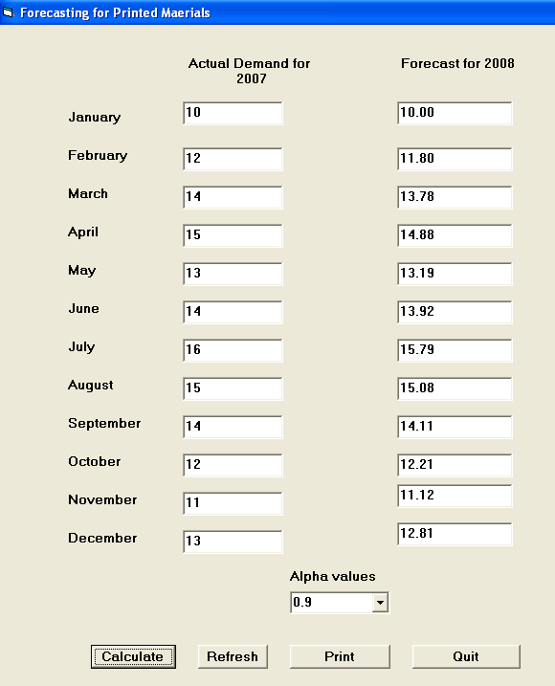
Figure 4.1 Computed Forecast Values When Α = 0.9

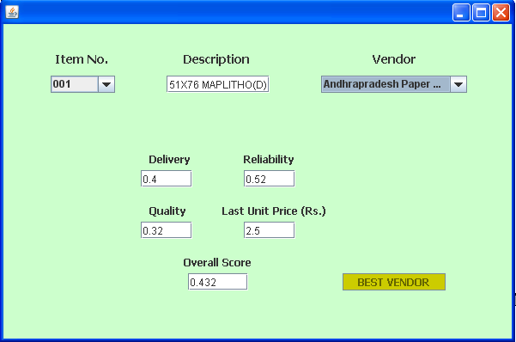
Figure 4.2 Performance of a Vendor for a Particular Item

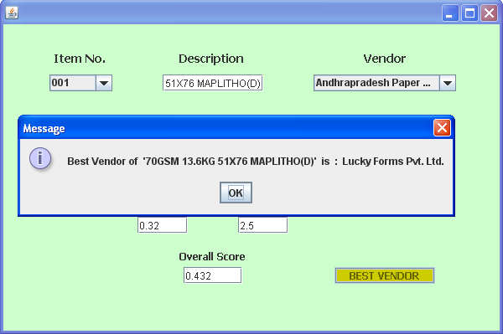
Figure 4.3 Selection of Best Vendor for a Particular Item

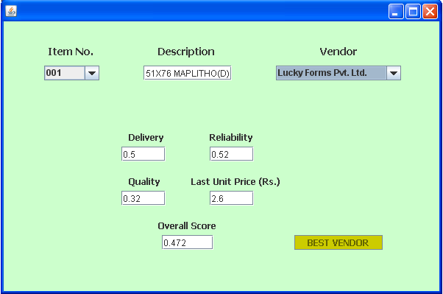
Figure 4.4 Performance Characteristics of Best Vendor
- References
- Moores, T.T., (1996), ‘Key issues in the management of information systems: A Hong Kong perspective, Information and Management’, Vol. 30, 301-307.
- Kusters, R.J. and Groot, P.M.A.(1996) ‘Modelling resource availability in general hospitals: Design and implementation of a decision support model, European Journal of Operational Research’, Vol. 88, 428-445.
- Nakashima, K., (1999), ‘A design for a management information system with consideration for stochastic variability’, International Journal of Production Economics, Vol. 60-61, 171-176.
- Beach, R., Muhlemann, A.P., Price, D.H.R., Paterson, A. and Sharp, J.A., (2000), ‘The selection of information systems for production management: An evolving problem’, International Journal of Production Economics, Vol. 64, 319-329
- Saxena, K.B.C. and Sahay, B.S., (2000), ‘Managing IT for world-class manufacturing: the Indian scenario’, International Journal of Information Management, Vol. 20, 29-57.
- Chiplunkar, C., Chattopadhyay, R. and Deshmukh, S. G., (2001) ‘Development of an integrated information management model: A case of textile industry’, Production Planning and Control, Vol. 12(6), 629- 645.
- Ranganathan, C. and Kannabiran, G., (2004), ‘Effective management of information systems function: An exploratory study of Indian organizations’, International Journal of Information Management, Vol. 24, 247-266.
- Sahin, F. and Robinson Jr., E.P., (2005), ‘Information sharing and coordination in make-to-order supply chains’, Journal of Operations Management, Vol. 23, 579-598.
- Baray,S., Hameed, S. and Badii, A, (2008), ‘Analyzing the factors responsible for effectiveness of implementation and integration of enterprise resource planning systems in the printing industry’, Journal of Enterprise Information Management, Vol. 21(12), 139-161.
- Jitendra Sharma, (2009), ‘A note on Quality Function Deployment’, Ivey Management Services, Version (A) 2009-11-18.
- P. Mukherjee, S. Chakraborty, B. Bhattacharya, (2011) ‘A Software Model for Managing Productivity in Small and Medium Commercial Printing Organizations’, Perspectives on Management, Vol. 3, pp 67-82.ISBN
- http://www.printfair.in/industry.htm accessed on 7/28/2013

